**Project Initialization and Planning Phase**

| Date | 14th July 2024 |
| --- | --- |
| Team ID | 739959 |
| Project Name | Sentiment Analysis of Commodity News(Gold) |
| Maximum Marks | 3 Marks |

**Define Problem Statements (Customer Problem Statement Template):**

Create a problem statement to understand your customer's point of view. The Customer Problem Statement template helps you focus on what matters to create experiences people will love. A well-articulated customer problem statement allows you and your team to find the ideal solution for your customers' challenges. Throughout the process, you’ll also be able to empathize with your customers, which helps you better understand how they perceive your product or service.

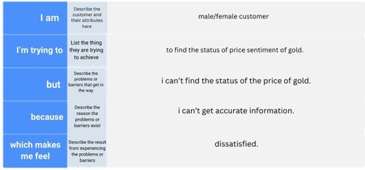

**Example:**

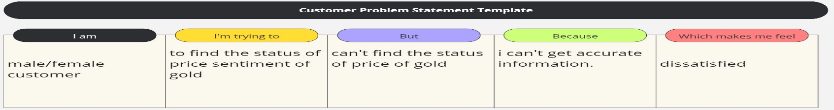

|  |  |  |  |  |  |
| --- | --- | --- | --- | --- | --- |
| **Problem**  **Statement (PS)** | **I am**  **(Customer)** | **I’m trying to** | **But** | **Because** | **Which makes me feel** |
| PS-1 | Male/female customer | Find analysis of gold | I didn’t find any analysis | I tried a lot | dissatisfied |
| PS-2 | Male/female customer | Find an accurate gold status | I didn’t get accurate status | I cant get accurate information | dissatisfied |